**Seminar on Using Library Facilities at CEAS Library** (Speakers: Mr. Ted Baldwin, Director of the Science and Engineering Libraries, UC; and Mr. Jim Clasper, Assistant Engineering and Applied Science Librarian; June 24, 2015, 9:00 am–10:30 am)

Mr. Ted Baldwin has been Director of the Science and Engineering Libraries since 2012. Previously, he was department head for the College of Engineering and Applied Science (**CEAS**) Library. He oversees services and staff at CEAS Library, and is responsible for purchasing journals and databases. He has also worked in industry, managing the Research & Development Library at Lyondell Chemical Company. Mr. Baldwin has a Master’s degree in Library Science from Indiana University (with a Specialist’s Certificate in Chemical Information), and BA from DePauw University, with majors in Music and Chemistry. He enjoys playing piano in various settings in the Cincinnati area.

Mr. Jim Clasper is an Assistant Engineering and Applied Science Librarian who is responsible for reference, bibliographic, access, and instructional functions in the CEAS Library. He answers reference questions and assist patrons in locating books, articles, conference papers, technical reports, standards, and patents by using the paper and electronic indexes available in the CEAS Library or elsewhere. Since 1995, he has been selecting monographic materials for the collection in the engineering disciplines of electrical, computer, mechanical, industrial, nuclear, aerospace, engineering mechanics, chemical, biomedical engineering, civil, environmental, and materials science engineering, He is responsible for selecting reference materials for the CEAS Library in all areas of engineering. He has been an engineering/science librarian for over thirty-six years. He received his MA degree in Library Science from the University of Wisconsin--Madison in 1975, and he also has a MA degree in History. He has been with the UCUC CEAS Library for over twenty-four years.

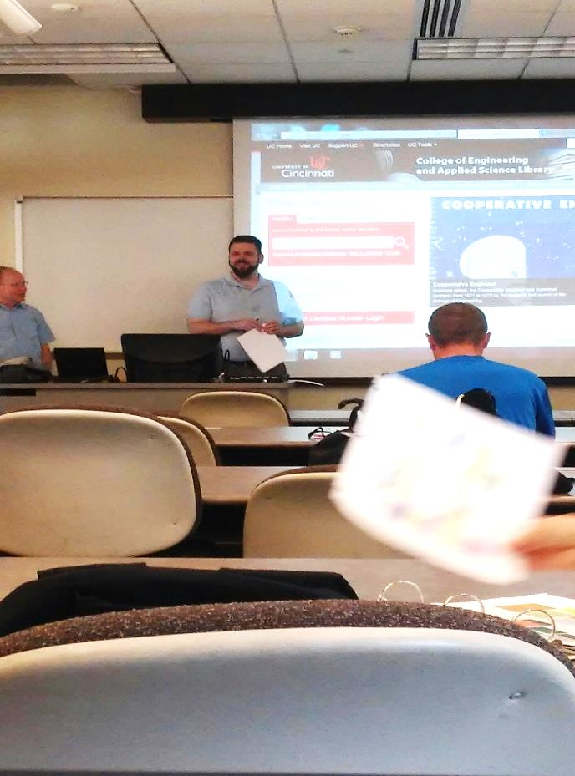

**Figure 1: Mr. Jim Clasper (Left) and Mr. Ted Baldwin (Right) During their Presentation**

The purpose of the seminar was for RET teachers to learn about resources available at UC to them to help them with their research papers. It was explained that they could use the website [http://www.libraries.uc.edu/ceas.html](http://www.libraries.uc.edu/ceas.html-) to find books in the UC libraries, but most research papers and references that will be used in their papers will be in electronic copy form.

The RET teachers then used the link <http://uc.v1.libguides.com/friendly.php?s=reu> to look at how they could obtain electronic resources. Under the REU/RET Research website, the main tab is labeled “REU/RET research guide” and below that their is a link labeled “ <http://uclid.uc.edu/search/X># “ which is where users can look up keywords to find electronic articles pertaining to their subject. This link allows users to look at UC’s electronic resources as well as OhioLink’s electronic resources.



**Figures 2 & 3:** **Pictures of UC’s Electronic Library Catalog**

Then Mr. Baldwin explained that on the website <http://uc.v1.libguides.com/friendly.php?s=reu>, the RET teachers could find their research exercise, which would be due in several weeks and would help the teachers research for their papers. The exercise involved finding one book and three articles and one conference paper that related directly to the thesis/project topic the teacher was working on. The assignment asks that the teacher explain how they found their resources and that they format their citations in ASCE format.



**Figure 4: Explanation of RET Assignment Online**

Mr. Kasper then explained that eBook collections such as Knovel, allow you to look at eBooks in a different way than what the library has. In the library collection you can look for keywords in the title, but in these eBook collections such as Knovel, you can search the entire text for keywords. Here is a list of all of the eBooks available that UC recommends <http://uc.v1.libguides.com/ceasebooks>

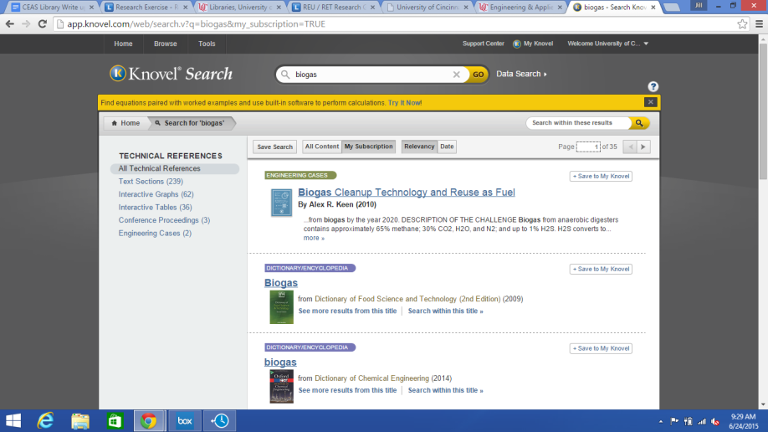

**Figure 5: Knovel a Public Search Engine for Articles**

Google Scholar is a resource that is being used more widely in Universities. This search engine allows for a user to look at date written, title, author, words in the text, and has many more uses. Another source that was mentioned was Engineering which houses a variety of science and engineering research papers. Engineering Village allows for the user to look at articles in different languages from people around the world. Another differentiating characteristic about Engineering Village is that when the keywords are typed in, a thesaurus is attached to the search box.

|  |  |
| --- | --- |
| **Figure 6: Engineering Village Website** | **Figure 7: Google Scholar** |

ASCE format is the reference format used in the research papers that the RET teachers must use. The presenters explained that the ASCE format is pretty prevalent in the science/research fields.